Estimation of burst rates in water distribution mains

Boxall, J. B.
Department of Civil and Structural Engineering, University of Sheffield, Mappin Blg. Mappin St. Sheffield. S1 3JD. UK. Tel. +(0)114 2225760 Fax. +(0)114 2225700 E-Mail. J.B.Boxall@Sheffield.ac.uk

O’Hagan, A.
Department of Probability and Statistics, University of Sheffield, The Hicks Building, Hounsfield Road, Sheffield, S3 7RH. UK Tel. +(0)114 2223773 Fax. +(0)114 2223759 E-Mail. a.ohagan@Sheffield.ac.uk

Pooladsaz, S.
Department of Probability and Statistics, University of Sheffield, The Hicks Building, Hounsfield Road, Sheffield, S3 7RH. UK Tel. +(0)114 2223854 Fax. +(0)114 2223759 E-Mail. s.pooladsaz@Sheffield.ac.uk

Saul, A. J.
Department of Civil and Structural Engineering, University of Sheffield, Mappin Blg. Mappin St. Sheffield. S1 3JD. UK. Tel. +(0)114 2225068 Fax. +(0)114 2225700 E-Mail. a.j.saul@sheffield.ac.uk

Unwin, D. M.
Department of Civil and Structural Engineering, University of Sheffield, Mappin Blg. Mappin St. Sheffield. S1 3JD. UK. Tel. +(0)114 2225416 Fax. +(0)114 2225700 E-Mail. d.m.unwin@sheffield.ac.uk

Abstract
The ability to forecast the burst behaviour of pipes in water distribution systems is a fundamental requirement of proactive planning for investment, replacement and rehabilitation strategies. However, burst behaviour is a complex function of many uncertain contributing factors. Attempts to develop accurate predictive models have been limited by: data quality and quantity; the lack of associations between individual events and pipes; and the statistical techniques available and applied.
Predictive expressions for annual burst rate in cast-iron and asbestos-cement pipes are derived for two sample datasets from the UK. The available data was interrogated to make rigorous associations between individual events and pipes and filtered for missing, default and erroneous data. Using statistical analysis, the theory of generalised linear models, it was then possible to derive predictive expressions for burst probabilities. The resulting expressions show strong associations between annual burst rate, diameter and length, and a complex association with age. Analysis was also undertaken to investigate associations with available soil data, a relative lack of consistent dependence of burst rate on this data is demonstrated.

Keywords
Water supply, bursts, statistical analysis, asset management

Introduction
There is a legacy of old and aging pipe work currently in operation in distribution networks around the world. For example many cities in the UK have significant proportions of their networks constructed of cast-iron pipes dating from Victorian times, 100+ years old. The consequences associated with ageing pipelines are likely to include increased water loss and an increase in the frequency of bursts. Such increases are not necessarily purely a function of age and hence a single number for ‘service life’ of a pipe is not necessarily conclusive of the need for rehabilitation or replacement.

The ability to confidently identify when a main has served its economically viable life is fundamental to planning and justifying rehabilitation and maintenance strategies. Economically viable life should be assessed by undertaking cost benefit analysis of avoiding customer disruption and continued operational and maintenance costs versus rehabilitation and replacement costs, such that the best long-term solution can be identified (Skipworth et al, 2002). One of the prerequisites of undertaking this, in a proactive manner is the ability to predict the expected burst behaviour of pipes. However, previous research has shown burst behaviour to be a complex function of a large number of variables, many of which are unknown or not directly quantifiable. Predicting the future burst behaviour of a pipe for which little or no burst data exists has proved difficult, and even models based on ‘grouped’ analysis have a high degree of uncertainty associated with them. There is potential for significant benefit from developing improved predictive models of burst rates, such that investment planning can be improved and maintenance and rehabilitation moved from reactive towards planned proactive strategies.

Background

Factors influencing mains failures
Water mains are exposed to a variety of physical, chemical and loading factors in their operating environment. These factors all interact in exerting an influence on the potential for failure. Many previous studies have investigated such causal factors, however significant controversy exists over the nature, relative importance and interaction of the possible explanatory variables.

Loading
A water main must be able to resist a variety of loading, some of which it is designed to resist and others that may result in failure.

Under ideal conditions a pipe is provided with uniform support over its entire length by the underlying media. However this may often not be the case, for example due to poor initial installation or disturbance over time (ground movement, disturbance by third parties etc.). A lack of support will result in a pipe acting as a beam, exposing it to longitudinal stresses and bending moments. The ability of a pipe structure to resist such forces is a function of the material strength and the second moment of the cross-section.

Pipes are designed to resist the internal pressure of the water that passes through them. Pressure is probably the single most important factor controlling leakage, hence to reduce and control leakage there have been widespread pressure management schemes in the UK since the early 1980’s. However, minimum feasible operating pressures are still constrained by local topography (Lambert, 1998) and operating requirements. Prior to pressure reduction work, operating pressures may have been significant and have caused structural weakening of pipe-work infrastructure. As well as equilibrium pressures, pipes may be exposed to far greater forces under transient conditions, induced by sudden changes in operational conditions, such as pump switching, power failure and valve movements. The ability of a pipe to resist the stresses induced by internal pressure is a function of the tensile strength of the material and wall thickness (Skipworth et al, 2002).

From this simplified review of pipe loadings it might be expected that pipe diameter and material are important factors in determining the burst behaviour of pipes.

Diameter
Smaller diameters have been associated with higher failure rates by several previous studies, such as Ciottoni (1983), Andreou and Marks (1986), and Walski et al (1986). Results of statistical analysis reported by Kettler and Goulter (1985) showed a strong correlation between average breakage rate and diameter, with some cases showing an almost linear decrease with increasing main size. These correlations were also a function of pipe material, for example strong correlation was found for cast-iron mains but not for asbestos cement mains. The modelling approaches of Shamir and Howard (1979) and Walski and Pelliccia (1982) also recognised inverse relationships between breakage rate and diameter.

Material
Material strength characteristics define the ability of a given pipe to resist the loads to which it is exposed. O’Day (1982) found that sand spun cast iron had a much higher failure rate than pit cast iron, showing that the method of manufacture influences tendency to fail. Material also dictates corrosion characteristics.

Corrosion
Structural deterioration of water mains, and in particular cast-iron pipes is primarily due to external corrosion. External corrosion of iron mains occurs primarily due to electrochemical reactions, four types that are of interest for water distribution systems are: uniform; localised; galvanic; and concentration cell corrosion (AWWARF, 1996). O’Day (1989) identified galvanic corrosion to be the primary cause of external deterioration, governed by the local soil properties, including resistivity, pH, redox potential and moisture content. Attempts have been made to model the reduction in pipe wall thickness as a result of corrosion in iron mains, Ahammed and Melchers (1994). The relationship is generally expressed as a power law in relation to age. Unlike iron mains, cement based pipes undergo degenerative chemical reactions rather than electrochemical corrosion (AWWARF, 1996). The reactions involve the leaching of CaO, the binding constituent in the cement matrix. External corrosion is widely accepted as dominating internal corrosion in terms of structural deterioration. Internal corrosion will be influenced by water quality. Although modern treatment control ensures that the corrosivity of potable water is kept to a minimum, historic exposure may be uncertain. These corrosion processes may be primarily related to pipe age, as a measure of time of exposure.

Age
Previous studies have suggested that age alone is a poor indicator of the necessity for pipe replacement or rehabilitation. Herbert (1994) noted the usefulness of age as a measured, but concluded that it must be combined with knowledge of network condition and weak points to allow accurate assessment. From operational experience Dyachkov (1994) reported that certain pipelines that had already worked out their ‘rated useful service life’ were satisfactory. O'Day (1982) also reported that age alone was a poor indicator of burst rate for a study of cast iron mains. Although these studies and others note that age alone is a poor indicator of the likelihood of pipe failure, some studies have reported direct association between age and burst rate. For example, Kettler and Goulter (1985) found a strong correlation between the age of an asbestos cement main and its burst rate, and Pascal and Revol (1994) found that the number of breaks in cast-iron pipes increased with age.

Leakage levels reflect bursts, and background leakage has commonly been associated with system age, for example Francis (1994). Butler and West (1987) stated that in the UK, average system age was around 50 years and that average leakage figure around 30%, in contrast two Water Companies in Germany, and three in Holland with average systems age of between 20 and 25 years had leakage levels from 2% to 15%.

Clearly there is some discrepancy in the association between age and pipe failure. However age does gives an indication of the length of time that a main has been in operation, exposed to the surrounding environment, and the time it has been subject to both internal and external loads. Age may also be considered as a surrogate indicator of the design and construction practice and the quality and strength of the material itself, although such factors would not be expected to result in predictable or smooth trends.

Quality of installation and workmanship
Pipe failure may sometimes be linked to its installation. Areas of weakness may be introduced through incorrect or rough handling, or if poorly controlled the fill used around a main could cause damage or uneven loading. Failure due to improper bedding due to poor practices or a lack of material can also be associated with the pipe length.

Length
The length of a pipe may be expected to be related to burst rate as a linear function, the longer the pipe the more there is to be exposed to conditions promoting bursting, such as poor support from surround fill or ground movement. Conversely length may be indicative of variability in the surrounding environment, longer lengths may be representative of rural areas with relatively uniform conditions, while shorter lengths may represent built up, urban areas possibly with more variable support, ground conditions and surroundings, this would lead to shorter pipes having higher burst rates per unit length. Length may also be considered as a surrogate for connection density, and if connections are considered as a point of weakness, shorter pipes may exhibit higher burst rates than longer pipes (Skipworth et al 2002).

Ground conditions
Stresses leading to pipe failure may be induced in pipes due to ground movement (Lackington (1991), Pascal and Revol (1994), Dyachkov (1994), Skipworth et al (2002)). Greek (1997) cited an estimate that a quarter of the UK supply network was laid in highly aggressive and/or shrinkable soil and that there was strong evidence that pipe bursts caused by corrosion and fracture correlated with soil factors. In a study of cast iron pipes Tsui and Judd (1991) reported that 30% of the mains assessed failed due to corrosion, and that the majority of these occurred in highly aggressive soils, with prevalent shrink/swell characteristics. Jarvis and Hedges (1994) concluded that soil corrosivity maps provided a sound basis for partitioning pipes into areas of equal corrosion risk, and Grau (1991) provided worldwide reports of the use of soil maps for highlighting areas of high burst risk. It is useful to note that all of these studies appear to have considered soil properties with respect to burst rate in isolation of any of the other possible explanatory variables.

Francis (1994) suggested that the ground movement causing bursts was associated with traffic loading. However Pascal and Revol (1994) report that there was no association between bursts, traffic loading or the position of pipes, and Marshal (1999) reported that the response of fill to dynamic traffic loading was elastic with no permanent increase in external pressure on the pipe.

Burst History
To all the above factors may be added the specific burst history of any particular pipe. Using regression analysis, Clark et al (1982) found that after first failure, the number of failure events increased exponentially with time. Similarly in a study restricted to pipes greater than 200mm diameter (on the basis that smaller pipes were mostly influenced by seasonal effects) Andreou and Marks (1986) found that the time to next break decreased as each break occurred. Goulter and Kazemi (1988) reported that 22% of failures occurred within a metre of a previous failure, and 46% within 20 metres of another failure. A number of explanations may be suggested for such occurrences including soil movement caused by the changing moisture content from the leaking water, or exposure of the soil to the extreme cold of the air and disturbance of the bedding during repair (Skipworth et al 2002).

Overall the mechanisms leading to pipe failure are often a combination of loading and structural deterioration, which are likely to be related to material, diameter, length and age.

Modelling mains bursts
The ability to predict burst probability (and any other performance criteria) is highly desirable for activities such as investment planning and scheduling maintenance. Pipe level performance modelling is of particular importance for life cycle analysis techniques (Skipworth et al, 2002), and consistent with the proactive nature of current regulatory drivers (OFWAT, 2000).

Load models
The external and internal loadings that a pipe may be exposed to at any particular time are very difficult to predict. Loadings will vary in magnitude both temporally and spatially, and historical conditions are likely to be largely unknown. Quantification of loading must be deterministic, although ultimately a stochastic based analysis is needed to model temporal and spatial variability of the identified loads. Two approaches, Ahammed and Melchers (1994) and Hadzilacos et al (2001), have attempted to determine the likelihood of pipe failure by quantifying the loads pipes are exposed to. However both model approaches concur that the information required to accurately determine pipe loadings, and hence the forces they create, are well beyond that available to most water companies.

Statistical lifetime models
Statistical models can be distinguished according to the level of detail required in the source data. First consider those that attempt to model a pipe’s burst rate over its lifetime. Such models require data in the form of complete burst histories for each pipe in a given dataset. Such detailed data allows the fitting of models that distinguish time to first failure from time to second failure, and so on, modelling each time lag in terms of other pipe characteristics such as diameter. Clarke et al. (1982) claimed to demonstrate decreasing mean time to each successive failure, although their statistical methods appear to have been subject to appreciable biases. Like Clarke et al. (1982), Andreou et al. (1987a & b) defined two periods in a pipe’s lifetime. Based on US data they found that the time between failures decreased up to the third event, after which it was constant. To describe the early deterioration behaviour they used a Cox proportional hazard model, and a Poisson distribution for the constant failure rate, enabling the prediction of the probability that a main will fail in a given time period. Similar methods were used by Marks et al. (1987). Herz (1996) and Lei and Saegrov (1998) developed probability based models to predict the useful life of a main, considered as the time to first failure.

Although such lifetime analyses provide some insight into failure mechanisms, they are impractical for informing decisions on management of distribution systems, since the detailed data are simply unavailable to most water companies. The vast majority of pipes are sufficiently old that full burst histories cannot be recovered from existing data.

Regression based models
Regression methods model the failure rate of pipe groups as a function of characteristics such as diameter and age. Such models can be fitted on the basis of data relating to a relatively short period of time, since no attempt is made to follow each individual pipe through its lifetime. This form of model is useful, as incident databases have typically only been rigorously maintained for around the last 10 years.

One of the first attempts to develop a model for mains burst rates was Shamir and Howard (1979). They used regression analysis to develop relationships between burst rate and age for homogeneous pipe groups, grouped with respect to diameter and material. It appears that non-linear regression models were not considered in these analyses. A consequence of this is that age appears linearly in the predictor of the logarithm of failure numbers. Hence the number of failures is predicted to be an exponentially increasing function of age. Walski et al (1986), and Mavin (1996) also used exponential based expressions to model burst rate. Instead of an exponential relationship between burst rate and age, Constantine et al. (1996) fitted a power relationship, including an unpredictable parameter to account for a variety of environmental, physical and loading factors.

A general criticism of the regression methods that have been derived hitherto is that they assume inappropriate statistical models. Burst data are counts, and it is incorrect to assume that counts, or the logarithms of counts, follow a normal distribution with constant variance, as is required by conventional regression models. See Kleiner and Rajani (2001) for further discussion of statistical models.

Both the lifetime and regression approaches, either explicitly or implicitly, have the ability to predict how a pipe’s burst rate evolves over time. However, the relationship to age determined in the above models is contradictory and often disputed. For instance, the finding of Andreou et al. (1987 a & b), that failure rate is constant after the third burst, is clearly at variance with predictive expressions, failure rate increasing with time according to an exponential or power law. The only absolutely proved link between time and deterioration is through corrosion, dominated by external corrosion, which has also been closely linked to soil conditions.

This modelling review has demonstrated that current modelling approaches often require data inputs beyond those available within most water companies, that there is considerable inconsistency in the form and importance of the contributing factors, and that some statistical analyses have assumed inappropriate statistical models. In this paper, generalised multiple regression models that more correctly represent count data will be applied to find new relationships for failure rates based on pipe characteristic data.

Methods

Typical data sources
Water utility companies within the UK maintain asset, incident and customer service record databases as a fundamental requirement for system understanding and management. These asset, incident and customer complaint datasets have typically (historically within the UK at least) been constructed and utilised independently of each other, stored in independently searchable, but unrelated databases. There is no distinct linkage or association between individual assets, bursts, identified leakage or customer service complaints: individual incidents such as bursts, identified leakage, repairs, and the various customer service complaints are not recorded in association with a particular asset, but are recorded at a geographical location or in the case of complaints to an individual property location. This lack of association of events and incidents to individual pipes severely limits the potential for data analysis and the derivation of performance models and causal associations. There is a need to develop functionality to facilitate pipe level association of such datasets, specifically automated (software) procedures to handle the large volumes of data involved.

Data available from most UK water companies, and deemed to be of interest for the derivation of burst models are:
Asset data:
- Unique pipe reference number
- Diameter
- Date laid
- Material
- Length
- Rehabilitation work carried out (including date of work)
- Date (if any) of abandonment
Incident / Customer service records
- Incident date
- Location (In X/Y coordinates or to a property reference number)
- Specific incident type
- Some comment of required action

Further to this information maintained by water companies, may be data in a regional format, polygons defining regions with specific characteristics. For example geographical, loading or soil data that may be of relevance for burst analysis.

Data preparation methodology

Asset and incident data associations
Information of the type indicated above can be formatted to be displayed and manipulated using Geographical Information Systems (GIS), if it is not already in a suitable format. This facilitates the utilisation of layering techniques and the development of proximity search techniques.

With the required data ordered into a common format within a GIS system, associations between individual assets and incidents can begin to be developed, based around proximity analysis of incidents to assets. Automated search routines can be written to undertake a proximity search for each incident in series, and will identify the closest pipes to the recorded location of the incident, hence creating pipe level associations. However, the use of proximity analysis alone is not suitable for relationship exploration, as an individual incident may in fact lay closer to an un-affected asset than the one it actually affected.

Figure 1 shows a graphical representation of an individual incident (in this case a burst) and its location relative to a selection of assets. Proximity analysis alone would incorrectly association this incident with one of the two pipes, to the left and below the incident. The correct asset (the one affected by the burst) is in fact the pipe directly above the incident on the map. Errors of this type occur from the recording of incidents to the property that reported the complaint, or by the technical/mapping operative incorrectly entering the incidents location co-ordinates. By extending the analysis to include association searches, utilising all other available common information in the un-related asset and incident databases, it is possible to reduce the number of incorrect associations. For example comments on repair work carried out may include notes on material type, and this can be verified against the material type in the asset database. Figure 2 provides an indication of incorrect associations that would have been made using proximity searches alone.

Using a hybrid of proximity and association searches it is possible to perform analysis in order to link individual incidents to the correctly affected asset. Thus developing pipe level incident data with a significant degree of confidence.

Association with regional data
Asset association to regional data may be desirable. The linking of assets that may or may not have been subjected to an incident to regional data again relies on proximity search techniques, searching for the closest polygon that individual pipes are entirely within. However this is complicated by the fact that pipes may cross one or more polygon areas. This complication may be overcome by ‘clipping’ pipes to individual regions, thus creating multiple pipes with consistent characteristics, one for each zone. These special pipe cases may then each be given an individual index number so as to differentiate between the pipe sections.

Filtering
Once all incidents have been linked to individual assets, many of the assets (affected and un-affected) will need to be removed from the dataset due to inconsistencies and missing data to create a new (smaller) complete database. The criteria for data removal utilised in these studies were, mains with unknown ages or material, mains with unrealistic age for example small diameter cast iron pipes with age less than 5 years, and diameter and length criteria such as mains with diameter greater than length and lengths greater than 1000 metres. Such filtering of data can only be undertaken once all incidents have been associated to individual assets, otherwise all mains and incidents are not considered for association analysis. This methodology, although time consuming, ensures that the incidents are linked to the correct main before any subsequent analysis takes place. During this work it has been found to be necessary to remove (subject to the criteria detailed above) between 30 and 50 percent of the available data. This high data removal was mainly due to either unknown material types or date laid values. It is quality rather than quantity of data that is required for derivation of performance models.

Although many datasets are incomplete and subsequently have information removed from them due to filtering, associated data of potentially great value for derivation of performance models may be obtained using the above procedure. Data loss could be reduced, for example through specific dig down surveys and the searching of company or local council archives. Although these data sourcing methods may appear to be initially expensive, the possibilities for improving the basic dataset are significant.

Statistical analysis
For the purposes of statistical analysis, the data from each company were partitioned according to material. It was expected that the detailed relationship between burst rate and age, diameter and length will be different in different companies and for different material types. However, a key component of this approach is to identify the underlying form of these relationships, which are expected to be consistent over different datasets. For example, it was expected to see the burst rate decaying with increasing diameter for all materials, but the rate of decay may be expected to differ not only between materials but also between companies.
From the data manipulation and associations detailed above, the number of bursts (N) over the period of observation, diameter (D), length (L), age in years / time since date laid (A) and the number of years of observation (Y) is available at pipe level. The statistical model that will be used for the analysis postulates that the number of bursts N experienced by a given pipe follows a Poisson distribution with mean λ(D, L, A)Y, where λ(D, L, A) is some function of diameter, length and age. Our model is formally a Poisson Generalised Linear Model (GLM) with logarithmic link function. This is a widely used member of the class of GLMs; see McCullagh and Nelder (1989).
A Poisson distribution is appropriate when the data are counts of events occurring randomly in time at a fixed rate, implying that there is a constant risk of failure not that times between failures has to be equal. It is assumed that each pipe experiences bursts occurring completely randomly at a constant rate of λ(D, L, A) per year over the period of observation. This is not perfectly realistic, since the pipe will age over the period of observation, which should therefore lead to the true burst rate changing over that period. However, this is believed to be a minor factor.
Various formulations have been considered for the function λ(D, L, A). The burst rate must be non-negative, so this function must produce a non-negative value for all possible D, L and A. Accordingly, all our models are in terms of γ(D, L, A) = log λ(D, L, A), which expresses the ‘logarithmic link function’ in our GLM. The GLM approach then proceeds as in conventional linear multiple regression models, by supposing that γ(D, L, A) can be expressed as a linear combination of terms involving the explanatory variables, and each such term has an unknown coefficient that is estimated from the data. Thus, in some sense the simplest such model would have the following form:
 | γ(D, L, A) = α + β_{D} D + β_{L} L + β_{A} A | Equation 1
This model implies that the burst rate λ(D, L, A) increases/decreases exponentially with diameter, length and age, which may not of course be the most appropriate kind of relationship to consider. The terms D, L and A can be replaced and/or augmented in Equation 1 by any function or functions of these variables. Furthermore, modern statistical techniques allow for the replacement of terms in the model specifying a particular parametric form of response to any given variable by an unconstrained nonparametric form. For instance, the response of the (log) burst rate to age is specified in the model (Equation 1) to have the linear form β_{A}A. This could be augmented to include, say, a quadratic form, so that the relationship might be β_{A}A + β_{A²} A². Both of these are parametric models, which constrain the relationship to have particular forms (the first being linear and the second quadratic). Nonparametric models do not constrain the form. An example is a spline function in which the statistical analysis estimates the number and location of ‘knots' for the spline. This facilitates examination of a huge variety of different models, depending on which terms and forms are included in the model. Statistical analysis allows determination of which of the priori plausible models (based on engineering knowledge) is best supported by the data, allowing identification of the ‘best' model.

Notice that the model assumes that two pipes of the same material, diameter, length and age will have the same burst rate. In practice, some pipes are expected to be more prone to bursting than others, due to the complexity of factors influencing failure as detailed previously. In principle, it might be possible to explain the differences in underlying burst rates by including more factors in the analysis, such as soil conditions, loading or pressure, however this is limited by data availability. Such unmodelled explanatory variables lead to extra variability in the data, which in the context of Poisson GLMs is known as ‘overdispersion’. This limits the accuracy of predictions in the same way as in any other regression analysis; more accurate predictions can be expected if the model is extended to include more explanatory variables. Following initial analysis two further explanatory variables were considered: soil shrink/swell and corrosivity indices.

Case study datasets
Two company specific datasets have been studied in detail to explore the relationships and ultimately the performance models that could be derived using the data association and statistical methods described above. Analysis has focused on cast iron and asbestos cement pipes, as these tended to have larger numbers than other materials in the study regions. Some analysis of plastic pipes revealed broadly similar behaviour. Figure 3 provides a graphical representation of the type and volume of data utilised.
Dataset 1: Data covering a large UK city. This dataset has customer service records and incident data for an eight year period and high quality GIS database asset information.
Dataset 2: Data provided by a large UK Water Company. Databases provided for one hundred district meter areas considered representative of the complete coverage of the company. This dataset was considered as a single group. Customer service records and incident data was available for a total period of eighteen years, however detailed records pertain to a 10 year period, together with good quality GIS databases of asset information.

Derived relationships

Relationship to diameter, length and age
Generalised linear models were applied to the data for each material and company, utilising a wide range of parametric and nonparametric forms to try to describe the observed burst behaviour in relation to the selected variables of diameter, length and age. Parametric model forms included quadratics, logarithms and interactions (i.e. product terms combining two or more different variables), with terms being included on the basis of a combination of statistical evidence and engineering knowledge. In particular, terms that were not found to be important in at least two datasets (other companies and/or other materials) were not included. This approach led to parsimony in the eventual fitted relationships, avoiding ‘over-fitting’ to the data in contravention of engineering knowledge. Only the final forms of the fitted models are presented here.

Nonparametric fits can represent the data more accurately, but have some disadvantages. Equations for the nonparametric fits cannot be readily written out and so are harder to give engineering interpretations to; they are also prone to some over-fitting. Nonparametric fits may be used to check the validity of parametric models. Close agreement between the parametric and nonparametric analyses indicates that the prediction of observed behaviour is good, with the parametric forms providing a tractable solution that can be readily utilised for predictive purposes.

In the following figures the relationship between burst rate and each of the physical parameters is visualised in isolation by plotting predictive trends using average values of each of the other variables; these are given in the sub title of each figure.

Diameter
Figure 4 shows the parametric and nonparametric relationships between annual burst rate and the variable diameter. The shape of the trends for both of the materials from each of the datasets is similar. The close agreement between nonparametric and parametric fits suggests that the relationships are well defined. The relationships are of an exponential form, similar to those presented by Skipworth et al (2002). This can be justified by consideration of the increase in structural rigidity through increasing second moment of larger cross sectional areas, hence a greater ability to resist various loadings and in particular bending stresses.

Length
Figure 5 shows the parametric and nonparametric relationships of annual burst rate with variable length. The shape of the trends for both of the materials from each of the example datasets is similar. Agreements between the parametric and non-parametric fits indicate good predictions. However, from Figure 5a, b and c, it is clear that the difference of annual burst rates from parametric and nonparametric fits increases with pipe length, this is due to reducing amounts of data, and the effect this lack of data has in constraining the statistical models.
The relationship found between burst rate and length is generally curved, rate of increase in burst rate decreasing with length. This suggests that doubling the length of a pipe does not double its annual failure rate. Splitting a pipe into two shorter lengths would give an implied higher combined failure rate than leaving the pipe whole. This may be explained if length is assumed to be in part a surrogate for connection density, as presented earlier.

Age
Unlike length and diameter, the relationship between annual burst rate and age is not simple and there is limited agreement between parametric and nonparametric fits, particularly at the extremes of the age ranges, Figure 6. Hence, nonparametric forms should be used to accurately describe this association. The parametric fits for CI pipes are implausible showing a decrease in burst probability with age, while this maybe acceptable for relatively short periods as explained through the concept of ‘burn in’ (Skipworth et al, 2002), the effect here is shown for periods up to 100 years. This apparently implausible relationship is due to age being more representative of year-laid associations; hence age may not necessarily show monotonic behaviour of increasing burst rate with increasing age. All pipes of a given age, in either dataset, represent a cohort in which practices were relatively consistent within the company, and may represent development or replacement / rehabilitation within a compact area within a region in which ground conditions and loading maybe relatively consistent. Age may therefore act as a surrogate for several explanatory variables that are not being measured such as design and construction practice, the quality and strength of the material, loading or ground conditions. Fluctuations in these variables can lead to appreciable changes in the subsequent performance of pipes from one annual cohort to the next. These considerations have important implications for the use of the fitted models.

Throughout Figure 4 to Figure 6 it is evident that cast iron pipes exhibit a higher failure rate than asbestos cement pipes. This might be expected for the diameter and length variables, as the cast iron pipes are on average older than the asbestos cement pipes, 60 years compared with 25 years. However, over the directly comparable age range, 20-60 years, for the same average values of diameter and length the annual burst rate is significantly higher for cast iron pipes than asbestos cement pipes, suggesting poorer burst performance of cast iron pipes compared with asbestos cement pipes.

Predictive expressions
The final fitted models are such that the predicted log burst rate is the sum of separate terms for each of the three explanatory variables, of the forms indicated above. Whilst some interaction terms were found in individual analyses, none of these emerged as having consistent predictive value between datasets.
The analysis of cast iron pipes for dataset 1 resulted in a generalised linear model of the following form:
γ(D,L,A) = 0.50247 - 0.00726D + 0.66252logL - 0.03375A + 0.00016A² | Equation 2
The analysis of cast iron pipes for dataset 2 resulted in a generalised linear model of the following form:
γ(D,L,A) = -0.59130 - 0.00721D + 0.76727logL - 0.01682A + 0.00012A² | Equation 3
The analysis of asbestos cement pipes for dataset 1 resulted in a generalised linear model of the following form:
γ(D,L,A) = -2.16853 - 0.00747D + 0.76018logL + 0.01803A | Equation 4
The analysis of asbestos cement pipes for dataset 2 resulted in a generalised linear model of the following form:
γ(D,L,A) = -2.89048 - 0.00930D + 0.56518logL + 0.01056A | Equation 5
These expressions provide the log annual burst rate, which can be converted into actual burst rate by evaluating the exponent, however the result is then no longer an unbiased estimator.

Equation 2 to Equation 5 indicate that the relationship between annual burst rate, length and diameter for cast iron and asbestos cement pipe groups for each of the two datasets are similar, with slight variation in the coefficient values. This is in part a product of the methodology followed for fitting the statistical models, however the close agreement between parametric and non-parametric models suggests robust relationships have in general been derived. However the agreement between parametric and non-parametric models for age was limited, hence non-parametric fits should really be used to describe the complex combination of factors being described by this variable. The ‘best fit’ of the parametric expressions of annual burst rate with age is given in Equation 2 to Equation 5. This relationship is different for asbestos cement pipes and cast iron pipes groups. However, the form of the relationship used for each material type is consistent between the two datasets, again with slight variation in the coefficient values. This similarity between the datasets suggests some continuity in the burst behaviour of pipes in the UK, but with different age relationships for different materials. This is again consistent with the concept of age acting a surrogate for many other variables, such as changes in the quality and strength of materials and design and construction practice with time.

Use of predictive expressions
Expressions of the form shown in Equation 2 to Equation 5 are invaluable for informing engineering decisions. Once the models have been derived for a given company or region it is possible to make predictions for every combination of material, diameter, length and age of pipe. These can be used directly to inform investment decision making and planning, or to inform whole life cost decision support procedures and software. It is important to recognise that this kind of burst rate prediction is valid principally for the short term, from perhaps 1 to 5 years. The prediction for a pipe of a given age is for its burst rate in the next year. Decay is a relatively slow process, so this rate can be expected to hold for up to 5 years. However, it would be inappropriate to predict on the basis of increasing the pipe’s age A each year, since that rate would apply to a different annual cohort of pipes, i.e. a pipe of age 10 years will not necessary “inherit” the burst performance of a current 15 year old pipe in 5 years time. In general this analysis is unable to throw light on the long term decay of pipes, because detailed burst records have only been maintained over a relatively small number of years. The appropriate model for that longer term decay is unknown, and accordingly these equations are not valid for prediction beyond a few years.

Relationship to soil conditions
Ground conditions were identified as one of the potentially important explanatory variables in the review of processes contributing to pipe failure. Ground conditions influence corrosion processes and, through ground movement and support, loading. Water companies do not typically maintain soil or ground condition data, however soil data is often available from external sources, for example from the National Soil Resources Institute at Cranfield University, UK. Such data was available for the regions of the two example datasets via the associated water companies. The above analysis was therefore extended and repeated including this soil data. The measures selected were shrink/swell index as an indicator of the propensity for ground movement, potentially a significant factor for failure of both asbestos cement and cast iron pipes, and corrosivity index, likely to influence the external corrosion of cast iron pipes. Shrink/swell index is ranked 1-5 with increasing volumetric shrinkage and class 6 for alluvial and peat soils (Farewell, 2004). Corrosion index is also ranked on a 1-5 scale, based on a weighted combination of: texture (particularly clay content); wetness class; acidity; carbonate content; and sulfate/sulfide content of a soil, corrosion index also includes a sixth classification for ‘rock within sub-soils’ (Farewell, 2004). Class 6 of the corrosivity index does not necessarily represent a greater corrosion risk. The two indices were available as regional data, defined by polygons. Pipe level associations to this regional data were made as detailed previously.

Figure 7 shows the resulting parametric and non-parametric relationships for asbestos cement and cast iron pipes to shrink/swell index for both datasets, it should be noted that only 1 pipe had shrink/swell index of 6, from dataset 2 cast iron pipes. The overall relationships seems reasonable, most figures suggesting a slight increase in annual burst rate with increasing shrink/swell index. However the resulting variation in annual burst rate is small compared to the other explanatory variables, suggesting a relative lack of dependence. The non-parametric fits are not ‘smooth’, for dataset 1 cast iron pipes showing a significant increase in burst rate with shrink swell index at level 5, however the number of pipes in the region of high shrink/swell index is very low, so this may be a misleading trend. Over all the quality of agreement between the parametric and non-parametric fits in Figure 7 are poor, providing limited confidence in the form of these associations.

Figure 8 shows the parametric and non-parametric trends obtained for the cast iron pipe groups from both of the example datasets as a function of corrosivity index, it should be noted that only 2 pipes had corrosion index of 6, from dataset 2 cast iron pipes. Up to an index value of 3 the nonparametric fits indicate an increase in burst rate. However, overall both the non-parametric fits, and the parametric fit for dataset 1, suggest a decrease in annual burst with increasing corrosivity index. This is contrary to the expected relationship and does not accord with engineering knowledge. Agreements between the parametric and non-parametric fits are poor, again providing limited confidence in these relationships.

It was hypothesised that through the introduction of soil data, improved predictive expressions would be obtained, and some of the heterogeneity in the age analysis in particular would be removed. However, the range of predicted burst rates associated with this soil data is small compared to those for age, length and diameter, agreement between parametric and non-parametric forms was poor and the predictive expressions remained largely unchanged. The range of predicted burst rates covered by the trends to shrink/swell and corrosivity index in Figure 7 and Figure 8, is about 0.01 to 0.02. In contrast the relationship with age covers a range of 0.07, length 0.18 and diameter 0.03, suggesting that the relative dependence on shrink/swell and corrosivity indices, compared to length and age in particular, is low. This is confirmed by the expressions of the form shown in Equation 2 to Equation 5, which remain largely unaffected by including these additional soil related explanatory variables, in particular no better resolution of the trend to age is obtained. A lack of agreement between parametric and non-parametric was seen previously for age, from which it was suggested that non-parametric fits should be utilised on the basis that age may be acting as a surrogate for many other explanatory variables, and hence not necessarily show a monotonic form. However, based on engineering knowledge soil data is expected to show a monotonic relationship, for example higher corrosivity should lead to higher burst rate in cast iron pipes. Hence the use of this soil data is not recommended either parametrically or non-parametrically.

This contradiction to previous research, which has suggested association between soil data and burst rate, may also be a function of the unique integration of explanatory variables in this analysis. After allowing for the other explanatory variables, the available soil data has little or no ‘additional’ predictive value. Other analysis seems to have used these variables alone and hence would not be expected to agree. It is possible to relate the lack of association between available soil data and burst rate to a number of other factors. The spatial resolution of the soil data used may have been insufficient to capture the localised effects of ground movement and corrosion processes effecting pipes on an individual basis. This analysis was based on available soil data at a 1km grid resolution with soil properties based on the dominant soil type/series. 100m resolution data is available from the National Soils Research Institute and could be used to address this limitation, however this data was not available for this project. Shrink/swell index is a measure of potential for movement and must be coupled with adverse loading or change in moisture content (particularly relevant in ‘sealed’ urban areas were soil moisture content is likely to be seasonally consistent) to lead to pipe bursts. It should also be noted that corrosivity is derived from available data and does not include resistivity, which is a key parameter controlling galvanic corrosion processes (AWWARF 1996), this data is currently being collated in the UK.

Conclusion
- The potential for improving knowledge by statistical analysis of pipe level associated and filtered asset and incident data derived from records currently maintained by UK water companies is clearly demonstrated.
- The relationship between burst rate and diameter has been found to increase exponentially with decreasing diameters. This can be readily explained by the increase in structural strength of larger cross sectional profiles.
- The relationship between burst rate and length has been found to be slightly curved, with a decreasing rate of increase in burst rate with length. This can be explained if length is considered as a surrogate for connection density, and joints considered as points of potential weakness.
- The relationship between burst rate and age is complex and is difficult to specify in a robust manner, as different analyses tend to produce different trends. This is probably due to the fact that age is likely to act as a surrogate for many other explanatory variables that are not maintained in databases, for example design and construction practice, the quality and strength of the material itself, exposure to loading or ground conditions. Nonparametric fitting of the age relationship will produce a relationship that represents the data, but the resulting model cannot be written down explicitly and has no interpretive value. In the absence of a reliable age relationship, it is only possible to make short-term predictions of burst rates.
- The relative lack of reasonable association between burst rates and available soil data has been demonstrated. It is thought that this may be due to the spatial resolution of the source data being insufficient to capture the local soil condition variability influencing local corrosion processes and ground movement, and in the case of shrink/swell index because this is only an indication of potential for movement and must be combined with change in moisture content, loading etc. This finding is contradictory to some previous research, and is related to the unique integrated analysis of explanatory variables in this study.

Acknowledgements
The authors gratefully acknowledge the financial support of the UK Engineering and Physical Science Research Council (grant no. GR/N25961) and the contributions of industrial partners: Bristol Water; Northumbrian Water; South West Water; United Utilities; Water Service - Northern Ireland; and Yorkshire Water Services.

References
Ahammed, M. and Melchers, R. E. (1994). “Reliability of underground pipelines subject to corrosion.” Journal of Transport Engineering Division ASCE, 120 (6), 989-1002.
Andreou, S. A. and Marks, D. H. (1986). “Maintenance planning strategies for large diameter cast-iron mains.” AWWA Conference Synopsis, 365-372.
Andreou, S. A., Marks, D. H. and Clark, R. M. (1987a). “A new methodology for modeling break failure patterns in deteriorating water distribution systems: Theory.” Advances in Water Resources, 10, 2-10.
Andreou, S. A., Marks, D. H., and Clark, R. M. (1987b). “A new methodology for modeling break failure patterns in deteriorating water distribution systems: Applications.” Advances in Water Resources, 10, 11-20.
AWWARF (1996). “Internal Corrosion of Water Distribution Systems.” Denver, American Water Works Association.
Butler, M. and West, J. (1987). “Leakage prevention and system renewal.” Pipeline Management Seminar, 1987, Pipeline Industries Guild
Ciottoni, A. S. (1983). “Computerised data management in determining causes of water main failure.” 12th International Symposium on Urban Hydrology, Hydraulics and Sediment Control, University of Kentucky, Lexington, Kentucky, 323-329.
Clark, R. M., Stafford, C. L. and Goodrich, J. A. (1982). “Water distribution systems: a spatial cost evaluation.” Journal of Water Resources Planning and Management Division ASCE, 108 (WR3), 243-255
Constantine, A. G., Darroch, J. N., and Miller, R. (1996). “Predicting Underground Pipe Failure.” Australian Water Works Association.
Dyachkov, A. (1994). “Rehabilitation of the water distribution in the city of Moscow.” Water Supply Congress, International Water Supply Association, 12 (1/2, Zurich), 89-94.
Farewell, T (2004) Personal communication with National Soils Research Institute, Cranfield University, Silsoe
Francis, C. (1994). “Sieving the evidence on leakage.” Water and Waste Treatment, DR Publications, London
Goulter, I. C. and Kazemi, A. (1988). “Spatial and temporal groupings of water main pipe breakage in Winnipeg.” Canadian Journal of Civil Engineering, 15, 91-97.
Grau, P. (1991). “Problems of external corrosion in water distribution systems.” Water Supply Congress, International Water Supply Association, International Reports, 9 (3/4) 5-1, 5-45
Greek, D. (1997). “Technological fingers in the dyke.” Professional Engineering, Nov 1997
Hadzilacos, T., Kalles, D., Preston, N., Melbourne, P., Camarinopoulos, L., Eimermacher, M., and Kallidromitis, V. (2001) “UTILNETS: A Water Mains Rehabilitation Decision Support System” [online] Computers, Environment and Urban Systems, special issue on Urban Knowledge Engineering. Available from: http://dke.cti.gr/pubs/journals/ceus00.pdf
Herbert, H. (1994). “Technical and economic criteria determining the rehabilitation and/or renewal of drinking water pipelines.” Water Supply, 12 (3/4, Zurich), 105-118.
Herz, R. K. (1996). “Ageing processes and rehabilitation needs of drinking water distribution networks.” J. Water SRT - Aqua, 45 (5), 221-231.
Jarvis, M. J. and Hedges, M. R. (1994). “Use of soil maps to predict the incidence of corrosion and the need for iron mains renewal.” Journal of the Institution of Water Environment Management, 8, 68-75.
Kettler, A. J. and Goulter, I. C. (1985). “An analysis of pipe breakage in urban water distribution networks.” Canadian Journal of Civil Engineering, 12, 286-293.
Kleiner, Y. and Rajani, B. B. (2001). “Comprehensive review of structural deterioration of water mains: statistical models.” Urban Water, 3 (3), 131-150.
Lackington, D. W. (1991). “Leakage control, reliability and quality of supply.” Civil Engineering Systems, 8, 219-229.
Lambert, A. O. (1998). “A realistic basis for objective international comparisons of real losses from public water supply systems.” The Institute of Civil Engineers Conf., Water Environment 98 - Maintaining the Flow, London
Lei, J. and Sægrov, S. (1998). “Statistical approach for describing failures and lifetimes of water mains.” Water Science and Technology, 38 (6), 209-217
Marks, H. D., Andreou, S., Jeffrey L., Park, C., and Zaslavski, A. (1987). “Statistical models for water main failures” US Environmental Protection Agency (Co-operative Agreement CR810558) M.I.T Office of Sponsored Projects No. 94211. Boston, Mass.
Marshall, P. (1999). “Evaluation of Long Term Performance: The Behaviour of Buried Pipes.” UKWIR, Research No. 99/WM/20/12, 12.
Mavin, K. (1996). “Predicting Pipe Failure Performance of Individual Water Mains.” UWRAA, Research Report No. 114, 189.
McCullagh, P. and Nelder, J. A. (1989). “Generalized Linear Models” (2nd edition). Chapman and Hall.
O'Day, K. (1982). “Organising and analysing leak and break data for making main replacement decisions.” AWWA Journal, 74 (11), 589-594.
O'Day, K. (1989). “External corrosion in distribution systems.” AWWA Journal, 81 (10), 45-52.
OFWAT (2000). MD 161 “Maintaining serviceability to customers.” http://www.ofwat.gov.uk/aptrix/ofwat/publish.nsf/Content/maintainingserviceability
Pascal, O. and Revol, D. (1994). “Renovation of water supply systems.” Water Supply Congress, International Water Supply Association, 12 ((1/2) Budapest), 6-3, 6-7.
Shamir, U. and Howard, C. D. D. (1979). “An analytic approach to scheduling pipe replacement.” AWWA Journal, 71 (5), 248-258.
Skipworth, P. Engelhardt, M. Cashman, A. Savic, D. Saul, A. Walters, G. (2002). “Whole life costing for water distribution network management.” Thomas Telford Publishing, London, ISBN 0727731661
Tsui, E. and Judd, G. (1991). “Statistical Modelling of Water Main Failures.” UWRAA, Research Report No.33
Walski, T. M. and Pelliccia, A. (1982). “Economic analysis of water main breaks.” AWWA Journal, 74 (March), 140-147.
Walski, T. M., Wade , R., Sharp, W. W., Sjostrom, J. W. and Schlessinger, D. (1986). "Conducting a pipe break analysis for a large city." AWWA Conference Symposium, 387-402.
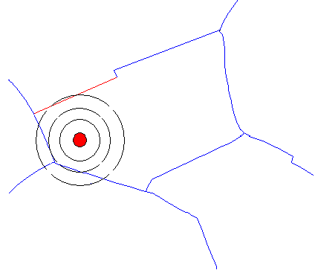
Figure 1. Graphical representation of proximity search to obtain pipe level association of a burst record.

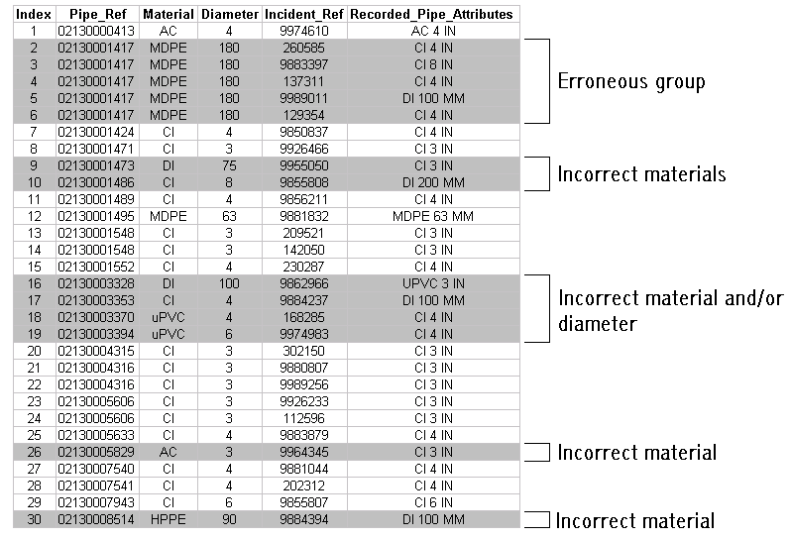
Figure 2. Example data highlighting the possible errors returned through use of proximity analysis alone

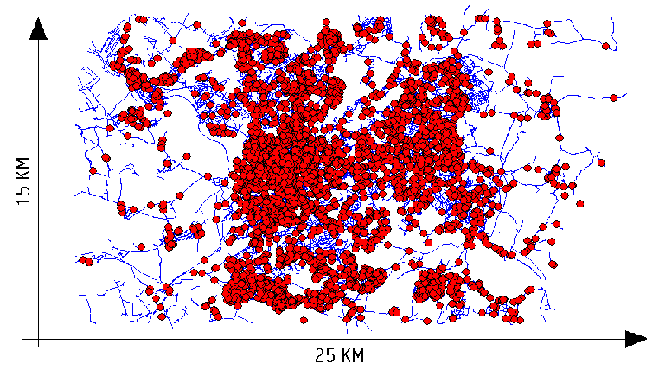
Figure 3. Example overview data plot. 36000 individual main sections, 22 material groups and diameters from 12.5mm to 1.5m, with 4335 individually recorded burst events

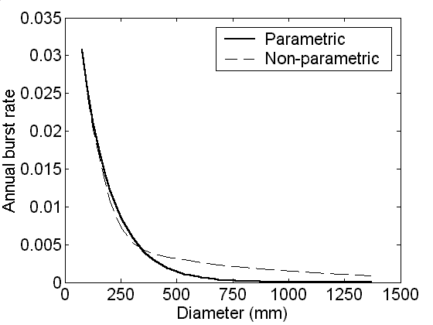  4a Dataset 1, cast iron pipes, A = 60 years, L = 0.05 km | 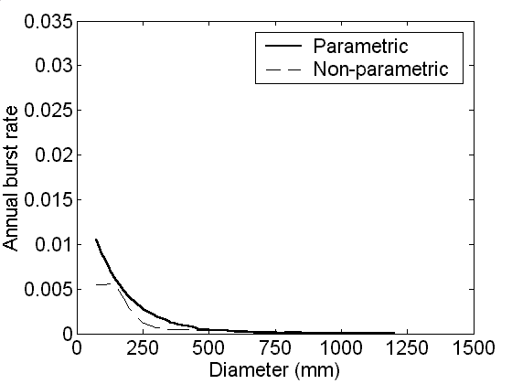  4b Dataset 1, asbestos cement pipes, A = 25 years, L = 0.05 km
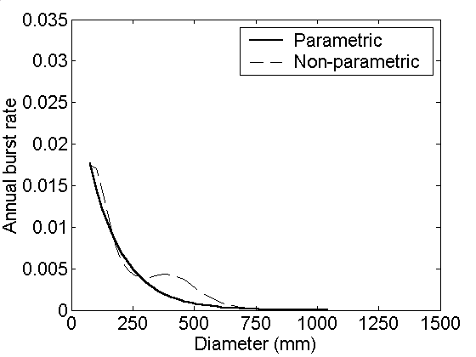  4c Dataset 2, cast iron pipes, A = 60 years, L = 0.05 km | 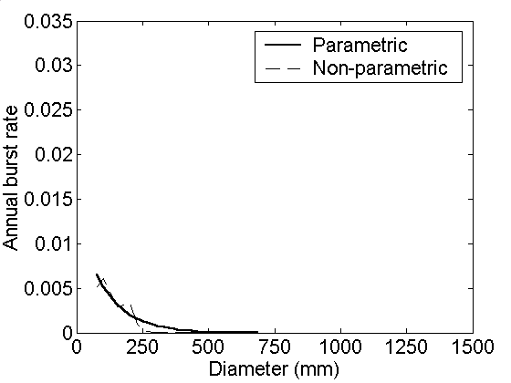  4d Dataset 2, asbestos cement pipes, A = 25 years, L = 0.05 km
Figure 4. Annual burst rate as a function of diameter

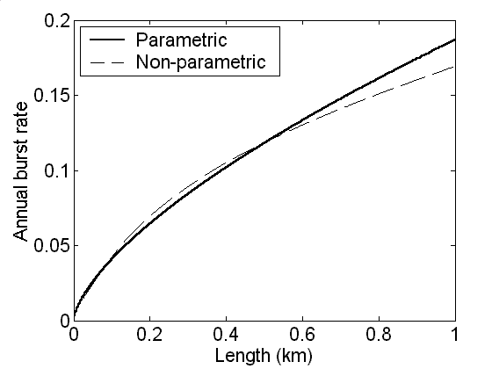  5a Dataset 1, cast iron pipes, A = 60 years, D = 101 mm | 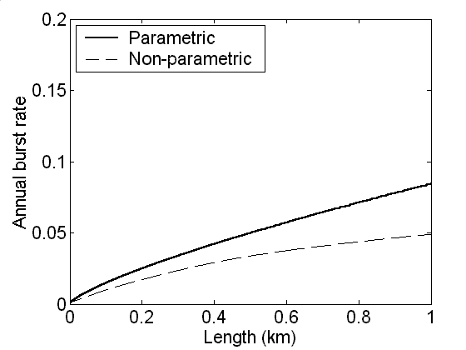  5b Dataset 1, asbestos cement pipes, A = 25 years, D = 101 mm
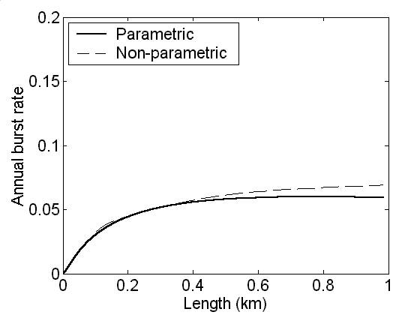  5c Dataset 2, cast iron pipes, A = 60 years, D = 101mm | 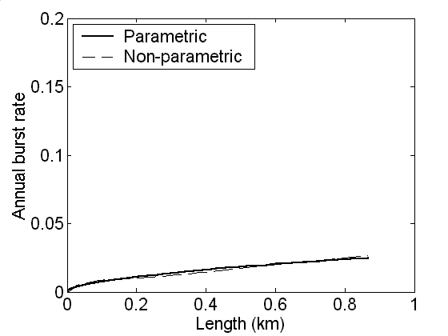  5d Dataset 2, asbestos cement pipes, A = 25 years, D = 4 in
Figure 5. Annual burst rate as a function of length

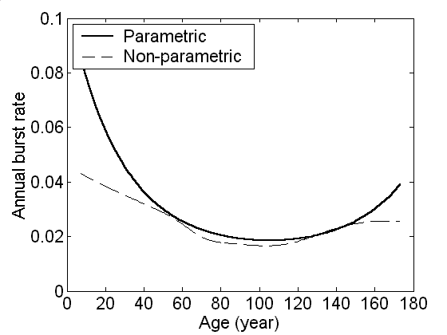  6a Dataset 1, cast iron pipes, D = 101 mm, L = 0.05 km | 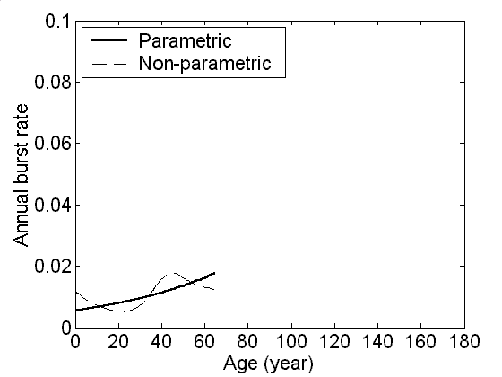  6b Dataset 1, asbestos cement pipes, D = 101 mm, L = 0.05 km
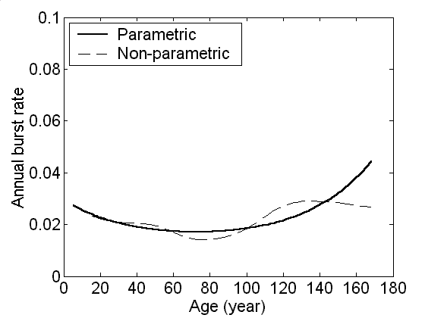  6c Dataset 2, cast iron pipes, pipes, D = 101mm, L = 0.05 km | 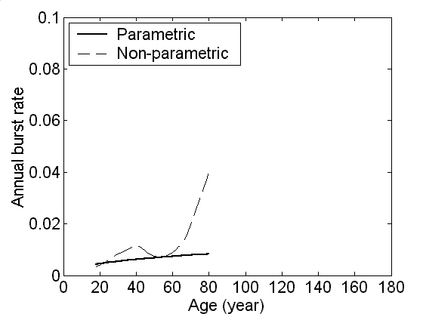  6d Dataset 2, asbestos cement pipes, D = 101mm, L = 0.05 km
Figure 6. Annual burst rate as a function of age

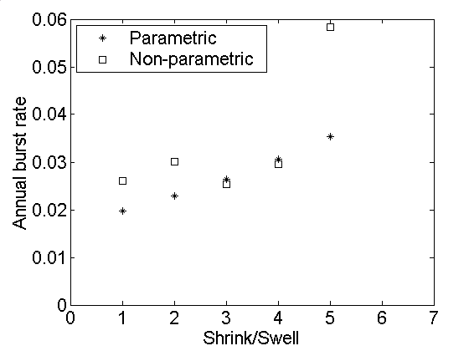  7a Dataset 1, cast iron pipes, A = 60 years, L = 0.05 km, D = 101mm | 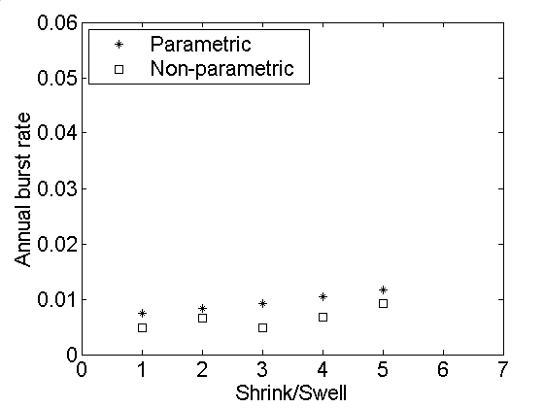  7b Dataset 1, asbestos cement pipes, A = 25 years, L = 0.05 km, D = 101 mm
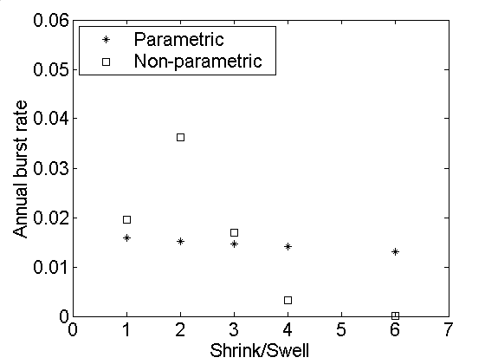  7c Dataset 2, cast iron pipes, A = 60 years, L = 0.05 km, D = 101mm | 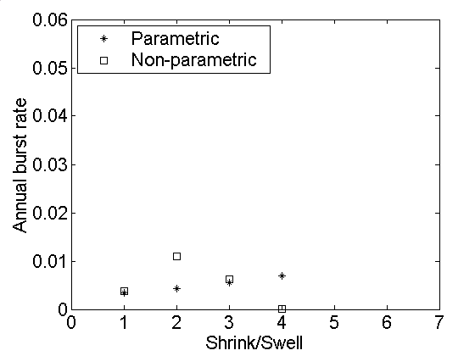  7d Dataset 2, asbestos cement pipes, A = 25 years, L = 0.05 km, D = 101mm
Figure 7. Annual burst rate for cast iron and asbestos cement pipe as a function of soil fracture potential data

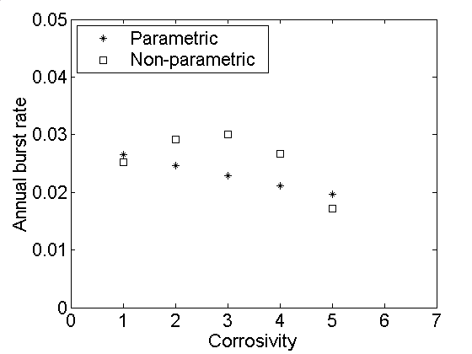  8a Dataset 1, cast iron pipes, A = 60 years, L = 0.05 km, D = 101 mm | 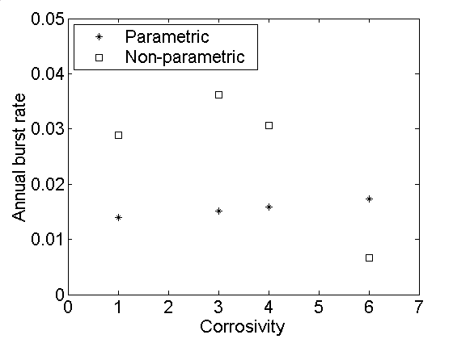  8b Dataset 2, cast iron pipes, A = 25 years, L = 0.05 km, D = 101 mm
Figure 8. Annual burst rate for asbestos cement and cast iron pipes as a function of soil corrosivity data

